C01 ASSESSMENT TOOL-3
NAME: R VARSHINI
REG NO: 192525349
COURSE CODE: CSA0307
COURSE NAME:DATA STRUCTURE
1).
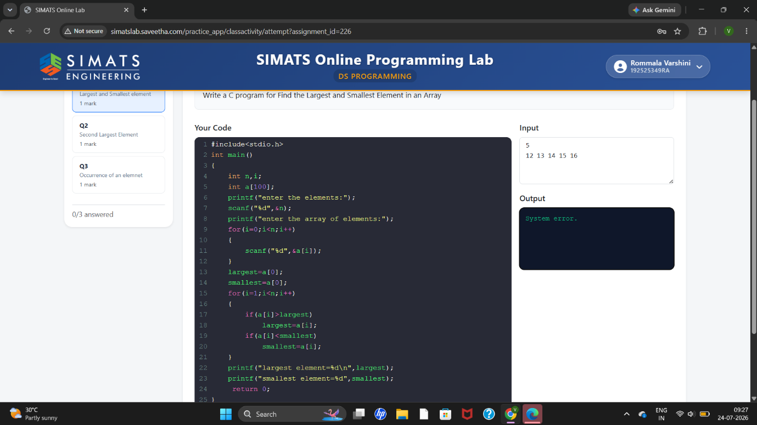
2).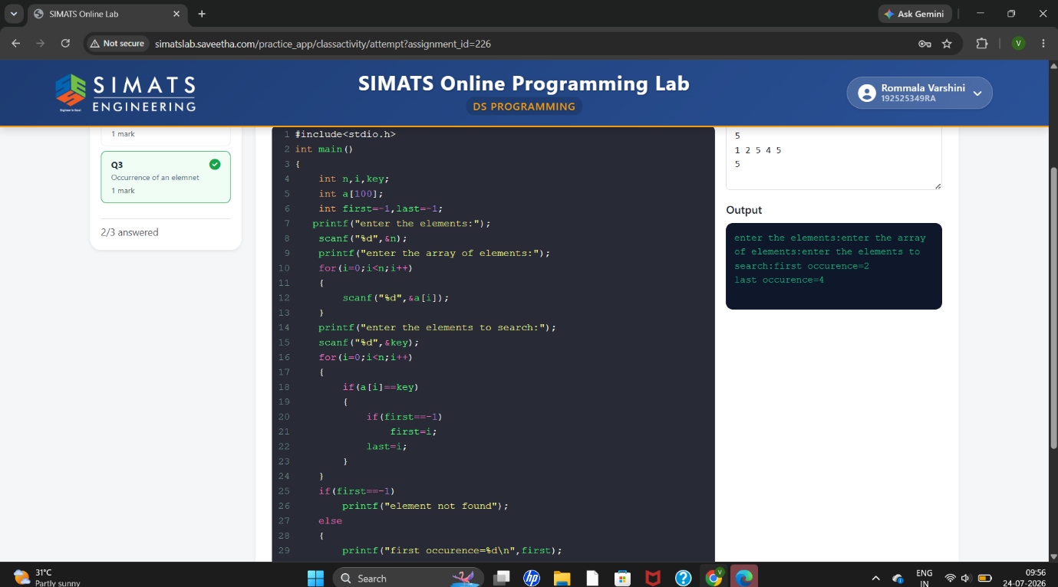
3).
